**ENTROPY**

The first law of thermodynamics introduces the concept of the internal energy U, and this term helps us to understand the nature of energy, as defined by the first law. In the similar way the second law introduces the concept of entropy S, like internal energy it is also a thermodynamic property and is defined only in terms of mathematical operations.

**General Discussion**:

For a system undergoing a quasistatic process, work done at the boundary is given by,



Since a reversible process is a quasistatic process this relation gives the work done at the boundary of a system during a reversible process.

Considering a reversible cycle in which only work involved is done at the boundary of the system, we have



Form the equation (2) ,Work is given by the cyclic integral of product of two properties

viz. P is an intensive property & dV is change in an extensive property.

For a reversible cycle when work (which is a path function) is defined by the product of two properties one is intensive and the other is change in an extensive property, why can’t Heat (which is also a path function) is defined by the cyclic integral of product of two properties one intensive and the other change in an extensive property.

Yes, the intensive property most closely associated with heat is temperature and the other extensive property for this answer is ENTROPY. Total entropy is denoted by capital letter S and lower case ‘s’ represents the specific entropy, i.e. entropy / unit mass.

If entropy is an extensive property then what exactly is entropy?

**Entropy is –**

|  |
| --- |
| 1. The amount of Energy that is not available for work during a certain process |
| 2. A measure of the disorder of a system. |
| 3. Measure of disorganization or degradation in the universe that reduces available  energy, or tendency of available energy to dwindle. Chaos, opposite of order. |
| 4. The state of disorder in a thermodynamic system: the more energy the higher the  entropy. |
| 5. A measure of the dispersal or degradation of energy. |
| 6.A measure of the disorder or randomness in a closed system. For example, the entropy  of an unburned piece of wood and its surroundings is lower than the entropy of the  ashes, burnt remains, and warmed surroundings due to burning that piece of wood. |
| 7.The scientific measure of the disorder in a system; the greater the disorder, the greater  the entropy. |
| 8.The thermodynamic entropy S, often simply called the entropy in the context of  thermodynamics, is a measure of the amount of energy in a physical system that cannot  be used to do work. It is also a measure of the disorder present in a system. The SI unit  of entropy is J·K-1 (joule per Kelvin), which is the same unit as heat capacity. |
| 9."Entropy" is defined as a measure of unusable energy within a closed or isolated system  (the universe for example). As usable energy decreases and unusable energy increases,  "entropy" increases. Entropy is also a gauge of randomness or chaos within a closed  system. As usable energy is irretrievably lost, disorganization, randomness and chaos  increase. |

**Understanding entropy:**

One of the ideas involved in the concept of [entropy](http://hyperphysics.phy-astr.gsu.edu/hbase/thermo/seclaw.html#c4) is that nature tends from order to disorder in isolated systems. This tells us that the right hand box of molecules happened before the left. Using [Newton's laws](http://hyperphysics.phy-astr.gsu.edu/hbase/newt.html#ntcon) to describe the motion of the molecules would not tell you which came first.

**Example 1.**

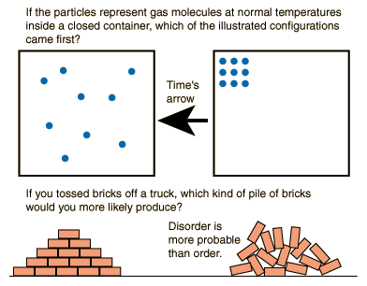

For a glass of water the number of molecules is astronomical. The jumble of ice chips may look more disordered in comparison to the glass of water which looks uniform and homogeneous. But the ice chips place limits on the number of ways the molecules can be arranged. The water molecules in the glass of water can be arranged in many more ways; they have greater "multiplicity" and therefore greater entropy.

**Example 2.**

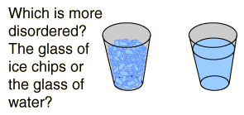

Solids have lesser entropy than liquids. Statistically, in solids the atoms or molecules are in their fixed places, whereas in liquids and even more in gases you never know exactly where to find them. The fixed sequence of atoms in solids reflects a higher ordered state.

Consider a body which is heated and another one is cooled. What happens to the entropy of the two bodies? Entropy increases on heating. Does disorder increase, too?

Yes, it does. We know that heat is stored in a piece of matter as the random motion of particles. The hotter a body, the more its atoms and molecules jiggle around. It is not difficult to identify disorder by faster jiggling motion.

CLAUSIUS THEOREM:

The thermal efficiency of reversible Carnot cycle is given by the expression,



Where TH and TL are the temperatures of high temperature thermal reservoir and low temperature thermal reservoir respectively, and QH is the heat supplied and QL is the heat rejected by the Carnot engine.

Considering the usual sign convention, +ve for the heat absorbed and –ve for the heat rejected, we may write,



Equation (2) shows that the sum of the quantities  , associated with absorption and rejection of heat by the fluid of a reversible heat engine is zero for the entire cycle. Since the working fluid returns to its initial state at the end of the cycle, it undergoes no net change in properties, suggesting that the quantities  represents property changes of the working fluid because their sum is zero for the cycle and this is the characteristic of a property or state function. The amount of heat transfer is known to depend on the path of the process. However if the heat is divided by the temperature at which the transfer takes place, the result is independent on the path.

The above conclusion is for the Carnot reversible cycle. But it can be proved that the conclusion is valid for any reversible cycle.

Consider any arbitrary reversible cycle a-b-c-d-a as shown. In such cycle absorption and rejection of heat do not occur at two constant temperatures but take place at continuously changing temperatures.



The cycle can be now broken into an infinite number elementary Carnot cycle by drawing a series of infinitely close adiabatic lines, eh, fg, mn, etc. efgh, fmng etc represents elementary Carnot cycle in which sections ef, gh etc can be considered as isothermal lines.

For any differential Carnot cycle, efgh, let QH1 be the heat absorbed during isothermal process ef and QL1 be the heat rejected during the isothermal process gh. The temperature of ef is TH1 and gh process is TL1.Then we may write,



Using proper sign convention +ve for the absorption of heat and -ve for rejection, we get,



Similarly,

 for the cycle fmng

From these relations we see that the algebraic sum of the ratios of the amounts of heat transferred to the absolute temperature for the Carnot cycles taken together is equal to zero, thus,



i.e. 

As the number of Carnot cycles is very large, the sum of the terms  over the complete cycle becomes equal to the cyclic integral of  , We may , therefore write



Where R represents reversible cycle. This result is known as **CLAUSIUS THEOREM.**  is known as **ENTROPY**.

**ENTROPY:**

Definition: Entropy , S is a property of system such that its increase **S2 - S1** as the system changes from state 1 to state 2 is given by,



In differential form equation (1) can be written as 

**THE CLAUSIUS INEQUALITY:**

When any system undergoes a cyclic process, the integral around the cycle of  is less than or equal to zero.

In symbols, 

Where **δQ is** an infinitesimal heat transfer**, T is** absolute temperature of the part of the system to which heat transfer **δQ** occurs**.**

**PROOF:**

For any reversible cycle from Clausius theorem,



From the Carnot’s theorem we know that the efficiency of an irreversible engine is less than that of a reversible engine, i.e. 

Where is efficiency of the irreversible engine and is efficiency of the reversible engine.

Hence, 

Where I and R represents irreversible and reversible processes respectively.

For a reversible engine, the ratio of the heat absorbed and heat rejected is equal to the ratio of the absolute temperatures. Therefore

 i.e. 

or  **i.e.** 

Using sign conventions of +ve for absorption of heat and –ve for the rejection of heat, we get,



From this we see that the algebraic sum of the ratios of the amounts of heat transferred to the absolute temperature for a cyclic irreversible process is always less than zero,



Combining equations (2) and (7), we get 

This is known as **CLAUSIUS INEQUALITY**.

**CLAUSIUS INEQUALITY** is helpful in determining whether the process is reversible or not.

If  **,** the cycle is reversible,  **,** the cycle is irreversible and possible and

 , the cycle is impossible since it violates the second law of thermodynamics.

ILLUSTRATION OF **CLAUSIUS INEQUALITY:**

Example 1. Consider the flow of heat from the reservoir at temp T1 to that at T2 across the conductor as shown. Conductor is the system. In the steady state there is no change in the state of the system.

T1

T2

**δQ1**

**δQ2**

A Clausius inequality

Let **δQ1 = 1000 kJ , T1 = 500 K**, **T2 = 250 K**

**Since δQ1 = 1000 kJ, δQ2 = -1000 kJ**

**, Hence**  **, proved.**

Example 2. E is the system which executes a cyclic process.



However, if E were a reversible engine, then work

δW would have been,

 and



**Hence**



500 K

250 K

E

1000 kJ

600 kJ

**δW**

Example 3.

A heat engine receives reversibly 420 kJ / cycle of heat from a source at 327 0C, and rejects heat reversibly to a sink at 27 0C. There are no other heat transfers. For each of the three hypothetical amounts of heat rejected, in (a), (b) and (c) below, compute the cyclic integral of **.** From these results show which case is irreversible, which reversible and which impossible. (a) 210 kJ / cycle rejected (b) 105 kJ / cycle rejected and (c) 315 kJ / cycle rejected.

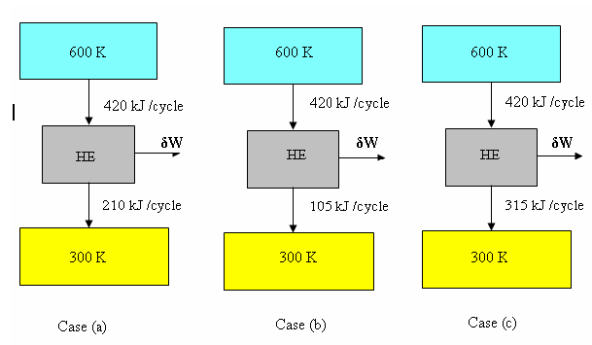

**Case (a)**

**, Since****, reversible**

**Case (b)**

**, Since****, Impossible**

**Case (c)**

 **, Since****, irreversible**

**ENTROPY IS A PROPERTY:**

Proof that entropy is a property:

**Statement:** For any system undergoing internally reversible cycle, the integral of  is zero, in symbols, 

Let the system executes a cyclic process, starting at state 1, proceeding to state 2 along the reversible path A, and returning state 1 along a different path B.

1

2

Reversible Path B

Reversible Path A

Y

X

From the Clausius inequality we have along path 1A2B1, 

Since the process is reversible, we may reverse it and thus cause the system to retrace its path precisely. Let the element of heat transfer corresponding to the system boundary at temperature T be **δQ’R ,** for this reversed process.

Then we have along path 1B2A1, 

But, since the second cycle is simple the first one with the direction reversed, we have,



Therefore, statement (3) becomes; along path 1B2A1, 

or 

Comparing statements (2) and (6) we see that they can be both true simultaneously only

if, , hence Entropy is a property.

**Statement**: The integral of  **,** when a system executes any reversible process between fixed end states, is independent of the path of the process.

In symbols, for arbitrary paths A and B, 

1

2

Reversible Path C

Reversible Path A

Reversible Path B

Y

X

Consider a system which executes a reversible cyclic process, from 1 along path A to 2, and back along path C to 1.Then we have,



Similarly, for the reversible cyclic process 1B2C1, we can write,



From equations (1) and (2) we get, i.e. (1) – (2) gives,



i.e. 

Path A and path B are arbitrary and  has the same value for any reversible

path between (1) and (2) , hence from the definition of entropy we may write ( S2- S1) has the same value for any reversible path between 1 and 2 . Therefore **ENTROPY** is a property.

**CALCULATION OF ENTROPY CHANGE FOR DIFFERENT PROCESS**

Entropy change in **IRREVERSIBLE** process:

For a process that occurs irreversibly, the change in entropy is greater than the heat change divided by the absolute temperature. In symbols,



Proof:

1

2

Reversible Path B

Irreversible Path A

V

P

Consider an arbitrary irreversible cycle 1-A-2-B-1 as shown in figure. The path 1 to 2 (1-A-2) is traversed irreversibly and the path 2 to 1 ( 2-B-1) reversibly. From the Clausius Inequality, we have

 **,** for the cycle which is irreversible and

 **,** for the cycle which is reversible ---------------------------- (1)

Since the entropy is a thermodynamic property, we can write 

For a reversible process we have, 

Substituting this in equation (2), we get



Using equation (1), for an irreversible cycle,



Now subtracting equation (5) from equation (4), we get



For small changes in states the above expression can be written as, 

Where the subscript I represents the irreversible process. The equation (7) states that in an irreversible process the change in entropy is greater than **.** Therefore we can write,

 , where equality sign is for reversible process and inequality sign is for irreversible process.

**IMPORTANT:** The effect of irreversibility is always to increase the entropy of the system. If an isolated system is considered, from the first law of thermodynamics the internal energy of the system will remain constant.  **,** from the above expression **,** i.e., the entropy of an isolated system either increases or remains constant. This is a corollary of the second law of thermodynamics and this explains the principle of increase in entropy.

**MATHEMATICAL EXPRESSION OF THE SECOND LAW**:

** for reversible processes and  for irreversible processes**

The above equation may be regarded as the analytical expression of the second law of thermodynamics.

**ENTROPY CHANGES FOR AN OPEN SYSTEM:**

In an open system the entropy is increased because the mass that crosses the boundary of the system has entropy. Thus for an open system, we may write,



Where, and are the masses entering and leaving the system & **,** are the entropies.

As the mass enters the system, the entropy is increased by an amount , similarly as the mass leaves the system, the entropy decreases by an amount 

In steady flow process there is no change in the mass of the system and **.** We can write, therefore



For steady flow adiabatic process   ( since  **)** i.e. in a steady flow adiabatic process the entropy of the fluid leaving must be equal to or greater than the entropy of the fluid coming in.

Since the equality sign holds for a reversible process, we conclude that for a reversible steady – flow adiabatic process,



**IMPORTANT RELATIONS FOR A PURE SUBSTANCE INVOLVING ENTROPY**

PURE SUBSTANCE:

A pure substance has a homogeneous and invariable chemical composition even though there occurs a phase change.

The first law for a closed system is given by,



In the absence of changes in kinetic and potential energies the equation (1) can be written as



For a reversible process 

Therefore equation (2) becomes



The work done at the boundary of a system during a reversible process is given by



Substituting this in equation (3), we get



From equation (5) we realize that it involves only changes in properties and involves no path functions. Therefore we conclude that this equation is valid for all processes, both reversible and irreversible and that it applies to the substance undergoing a change of state as the result of flow across the boundary of the open system as well as to the substance comprises a closed system.

In terms of per unit mass the equation (5) can be written as



Since (since H = U + PV)



Therefore

**i.e.** 

In terms of unit mass, 

or 

**PRINCIPLE OF THE INCREASE OF ENTROPY:**

**Entropy Change for the System + Surroundings**

Consider the process shown. Let δQis the heat transfer from a system at temperature **T** to the surroundings at temperature **T0, and** **δW** is the work of this process (either +ve or –ve ). Using the principle of increase in entropy

Surroundings Temperature = T0

System Temperature = T

**δW**

**δQ**





for a reversible process

The total change of entropy for the combined

system



The same conclusion can be had for an open system, because the change in the entropy of the system would be



The change in the entropy of the surroundings would be,



Therefore,  since  and it follows

that  and therefore 

This means that processes involving an interaction of a system and its surroundings will take place only if the net entropy change is **greater than zero** or **in the limit remains constant.** The entropy attains its maximum value when the system reaches a stable equilibrium state from a non equilibrium state.

**ENTROPY FOR AN IDEAL GAS :**

Let the ideal gas undergoes a change of state from state 1 to state 2. Let T1 , V1 and T2 , V2 be the temperatures and volumes at state 1 and 2 respectively.

We have, 

Since,  and  where m is the mass and R is the gas constant, we get

 therefore



If cv = constant, then



Similarly, we have 

Since,  we get, 

Therefore, 

If cp = constant, then 

For general case ( process ), change of entropy is given by,



or in specific values,



SPECIAL CASES:

1. Constant temperature process ( Isothermal process), T = Constant



1. Constant volume process , V = Constant



1. Constant pressure process , P = Constant



1. Reversible adiabatic process or isentropic process, S = Constant

Change in entropy is zero, 

1. Polytropic process



**Problems on entropy:**

**Problem No.1.** One kg of water at 273 K is brought into contact with a heat reservoir at 373 K. When the water has reached 373 K, find the entropy change of water, the heat reservoir and of the universe.

**Solution**: Let T1 be the temperature of water, T2 be the temperature of heat reservoir. Since reservoir is at higher temperature than that of water, when water is brought into contact with the reservoir heat transfer occurs from reservoir to water and takes place through a finite temperature difference (irreversible). The entropy of water would increase and that of reservoir decrease so that net entropy change of the water and the reservoir together would be **+ve definite.** To find the entropy change of water we have to assume a reversible path between end states, which are at equilibrium.

System (water)

T1 = 273 K

Heat reservoir

T2 = 373 K

**Q**

1. Entropy of water



2) The temperature of the reservoir remains same irrespective of the amount of the heat withdrawn.

Amount of heat absorbed by the system from the reservoir,



Therefore, Entropy change of reservoir,

 (-ve sign indicates decrease in entropy)

3) Entropy change of the universe



**Problem No.2.** Two kg of air is heated from 270C to 4270C while the pressure changes from 100 kPa to 600 kPa. Calculate the change of entropy.R = 0.257 kJ / kg K, Cp = 1.005 kJ / kg K.

**Solution:** Given:

|  |  |
| --- | --- |
| m = 2 kg |  |
| T1 = 27 + 273 = 300K  T2 = 427 + 273 = 700K | P1 = 100 kPa  P2 = 600 kPa |

The general equation used for the calculation of change of entropy is given by,



**Problem No.3.** Ten grams of water at 20 0C is converted into ice at - 10 0C at constant atmospheric pressure. Assuming specific heat of liquid water to remain constant at 4.184 J / g 0C and that of ice to be half of this value, and taking the latent heat of fusion of ice at 0 0C to be 335 J / g, calculate the total entropy change of the system.

**Solution:** Given :

|  |  |
| --- | --- |
| m = 10 gm |  |
| Water is available at temperature T1 = 20 0C = 293 k  Cp(water) = 4.184 J / g 0C  = 4.184 kJ / kg 0C | Ice is to be formed at temperature T4 = -10 0C = 263 K  Cp(ice) = ½ x 4.184 J / g 0C  = ½ x 4.184 kJ / kg 0C |

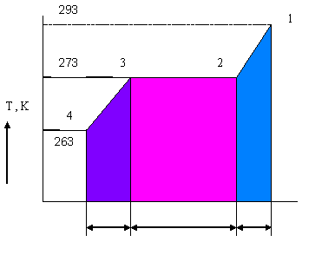

∆SIII

∆SII

∆SI

Total entropy change of water (system) as it is converted into ice will be



a)  i.e. entropy change of the system as it is cooled from 20 0C to 0 0C.



b)  i.e. entropy change of water at 0 0C.to become ice at 0 0C



c)  i.e. entropy change of ice as it is cooled from 0 0C to -10 0C



Therefore total entropy change of water as it is converted into ice will be



**Problem No.4.** A reversible engine as shown in figure during a cycle of operation draws 5MJ from the 400 K reservoir and does 840 kJ of work. Find the amount and direction of heat interaction with other reservoirs.

200 K

300 K

400 K

Q3

Q2

Q1 = 5 MJ

E

W = 840 kJ

**Solution:**

Let us assume that Q2 and Q3 are the heat rejected by the engine to the reservoir at 300 K and 200 K respectively.

From the Clausius theorem we have  i.e. 

And also, 

Consider equation (1), 

Using –ve sign for heat rejected in the equation, we have



and equation (2) gives, 

Solving equations (3) and (4), we get



Therefore the direction of heat interaction with the reservoirs are as follows

200 K

300 K

400 K

Q3 = 0.82 MJ

Q2 = 4.98 MJ

Q1 = 5 MJ

E

W = 840 kJ

**Problem No.5.** Two kg of water at 80 0C are mixed adiabatically with 3 kg of water at 30 0C in a constant pressure process of 1 atmosphere. Find the increase in the entropy of the total mass of water due to mixing process. Cp of water = 4.187 kJ / kg K.

**Solution:**

**Subsystem 1**

2 kg of water at 80 0C

**Subsystem 2**

3 kg of water at 30 0C

And t1› t2

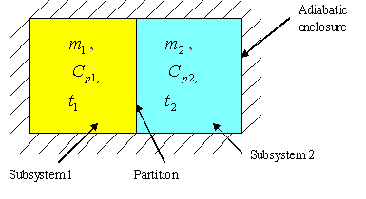

Let tf be the equilibrium temperature of the mixture of two subsystems

i.e. **Subsystem 1** + **Subsystem 2** and the final temperature tf  is such that t2 ‹ tf ‹ t1. Since energy interaction is exclusively confined to the two fluids, the system being isolated.

 since Cp1= Cp2 , tf will be given by



Entropy change for the fluid subsystem 1,



This will be negative since 

Entropy change for the fluid subsystem 2,



Increase in the entropy of the total mass of water due to mixing



Since  is + ve definite, the mixing process is irreversible.

**Problem No.6.** A steel tool of mass 0.5 kg at a temperature of 350 0C is plunged suddenly into an insulated vessel containing 10 kg of oil at a temperature of 20 0C. After a time the temperature of the contents of the vessel becomes uniform. Assuming the heat transfer to the atmosphere to be zero, and that none of the oil evaporates; evaluate the increase in entropy of the final contents of the vessel. Take Cp of oil = 1.88 kJ /Kg K and Cp of steel = 0.48 kJ /Kg K

**Solution:** Given

|  |  |
| --- | --- |
| **Steel** | **Oil** |
| **ts = 350 0C** | **toil = 20 0C** |
| **ms = 0.5 kg** | **moil = 10 kg** |
| **C steel = 0.48 kJ /Kg K** | **C oil = 1.88 kJ /Kg K** |

We take the steel and the oil as our system. Applying the principle of conservation of energy for this process, we get





Let **tf** be the final temperature of the contents of the vessel. We have for the energy balance



Now, entropy change for steel is,



And, entropy change for oil is



Therefore change in entropy of the final contents of the vessel,



**Problem No.7.** Calculate the entropy change of the universe as a result of the following processes

1. A copper block of mass 0.6 kg and specific heat 150 J/kg K at 100 0C is placed in a lake at 8 0C.
2. Two such blocks at 100 0C and 0 0C are joined together.

Solution:

Given:





When hot copper block is put into lake, the block shall cool down to the lake temperature since lake is big and treated as sink.











Let Tm be the equilibrium temperature of the two copper blocks when they communicate. i.e. **Copper block 1** + **Copper block 2** and the final temperature Tm  is such that Tc2 ‹ Tm ‹ Tc1. Since energy interaction is exclusively confined to the two blocks, the system being isolated.









**Problem No.8.** A heat engine is supplied with 278 kJ / s of heat at a constant fixed temperature of 283 0C and the heat rejections take place at 5 0C. The following results were reported.

i) 208 kJ / s of heat rejected. ii) 139 kJ / s of heat rejected. iii) 70 kJ / s of heat rejected.

Classify which of the results report a reversible cycle, irreversible cycle or impossible cycle.

Solution:

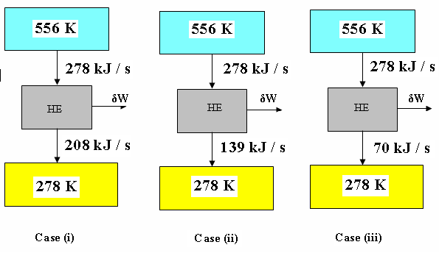

**Case (i)**

**, Since** 

**Case (ii)**

**, Since** 

**Case (iii)**

 **, Since** 

**Problem No.9.** 0.5 kg of ice block at -10 0C is brought into contact with 5 kg copper block at 80 0C in an insulated container. Determine the change in entropy of i) ice block ii) copper block iii) the universe.

Given specific heat of ice = 2 kJ / kg K, Specific heat of water = 4.2 kJ / kg K, Specific heat of copper = 0.5 kJ / kg K, enthalpy of fusion of water at 0 0C = 334 kJ / kg.

**Problem No.10.** An inventor reports that she has a refrigeration compressor that receives saturated Freon-12 vapor at -20 0C and delivers the vapor at 1 MPa, 50 0C. The compression process is adiabatic. Does the process described violate the second law?

**Solution:**

State 1. Condition of Freon -12 at inlet to compressor– **saturated vapor at -20 0C**

State 2. Condition of Freon -12 at the exit of compressor – **1 MPa and 50 0C**

Referring the Freon -12 tables we get, at state 1, **s1= 0.7082 kJ/kg K** and at state 2,

**s2= 0.7021 kJ /kg K**

**For a steady state, steady flow, adiabatic process we can write second law as,**s2≥ s1, but for the given adiabatic process, s1> s2 therefore the process involve a violation of the second law and would not be possible.

**Problem No.11.**One kg of ice at -5 0C is exposed to the atmosphere which is at 20 0C. The ice melts and comes into thermal equilibrium with the atmosphere. i) Determine the entropy increase of the universe.

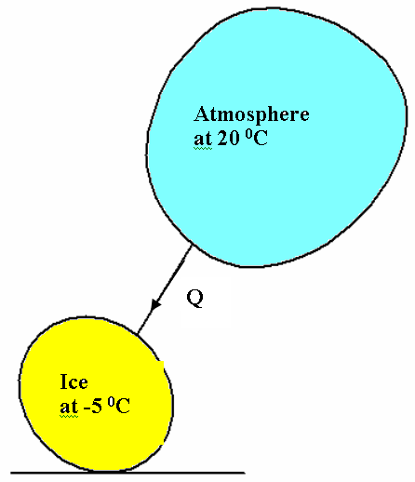

Heat absorbed by ice from the atmosphere is given by,



**Entropy change of the atmosphere**



a)  , entropy change of the system(ice) as it is heated from -5 0C to 0 0C.



b)  , entropy change of the system(ice) as it melts at 0 0C to become water at

0 0C.



c)  , entropy change of water as it is heated from 0 0C to 20 0C



Therefore total entropy change of ice as it melts into water will be



**Therefore entropy change of universe will be,**





**Problem No.12.** A 5 kg copper block at a temperature of 200 0C is dropped into an insulated tank containing 100 kg of oil at a temperature of 30 0C. Find the increase in entropy of the universe due to this process when copper block and the oil reach thermal equilibrium. Assume that the specific heats of copper and oil are respectively 0.4 kJ /Kg K and 2.1 kJ /Kg K.

**Solution:** Given

|  |  |
| --- | --- |
| **Copper block** | **Oil** |
| **tc = 200 0C** | **toil = 30 0C** |
| **mc = 5 kg** | **moil = 100 kg** |
| **Ccopper block = 0.4 kJ /Kg K** | **C oil = 2.1 kJ /Kg K** |

We take the copper block and the oil as our system. Applying the principle of conservation of energy for this process, we get





Let **tm** be the final temperature of the contents of the tank. We have for the energy balance



Now, entropy change for copper block is,



Now, entropy change for oil is



Therefore change in entropy of the final contents of the vessel,



**PROPERTY DIAGRAMS WITH ENTROPY AS A COORDINATE:**

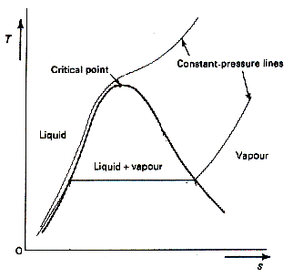

T

**s**

T

**s**

**Reversible Adiabatic**

**Irreversible Adiabatic**

This diagram is useful to analyze the nature of the thermodynamic systems to visualize the changes of state that occurs in various processes. This diagram possesses the following features.

1. Area on the diagram have the dimensions of heat
2. In the mixed-phase region, the constant pressure lines are horizontal
3. In a reversible process the area under the curve is equal to the heat transfer in the corresponding process
4. Vertical lines represents isentropic processes
5. In a reversible cycle, the area enclosed by the curve representing the process is equal to the net heat transfer to the fluid and so, from the first law is also equal to the net work.

If the substance executes a Carnot cycle, its path on the T-s diagram is a rectangle.

**T**

**s**

**b**

**a**

**c**

**d**

**TL**

**TH**

**Processes:**

**Process a-b: Isentropic Process**

**Process b-c: Isothermal Process**

**Process c-d: Isentropic Process**

**Process d-a: Isothermal Process**

Efficiency of the Carnot engine is given by,



An irreversible process is represented by a line tending to the right, for this entropy always increases.

**THE ENTHALPY –ENTROPY (h-s) diagram or MOLLIER diagram**

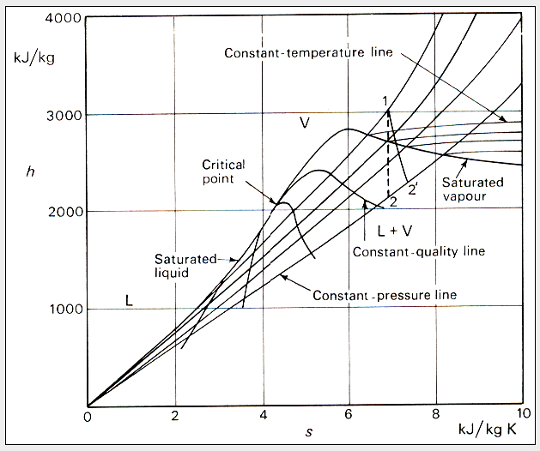

In the enthalpy-entropy diagram the pressure and temperature lines naturally coincide in the two-phase region.

Entropy postulations:

1. The entropy content of an isolated system can never decrease.
2. The entropy of any substance approaches a constant value as its temperature approaches absolute zero.
3. For a perfect crystalline substance, its entropy is zero at the absolute zero of temperature.

The nature of Entropy:

1. Entropy is a primitive concept
2. Every system has entropy
3. Entropy is an extensive property
4. Entropy is that –it is an index of that portion of energy content in a system that is not available to do work
5. Entropy content of an isolated system is not conserved.

**Available and Unavailable energy:**

We have,

|  |  |
| --- | --- |
| **High Grade Energy** | **Low Grade Energy** |
| 1 Mechanical Work  2 Electrical Energy  3 Water power  4 Wind power  5 Kinetic Energy of a jet  6 Tidal power | 1 Heat or Thermal energy  2 Heat derived from nuclear fission or fusion  3 Heat derived from combustion of fossil fuels |

The complete conversion of low grade energy, heat into high grade energy, shaft work is impossible.

That part of the low grade energy which is available for conversion is called as available energy, while the part which, according to the 2nd law of thermodynamics, must be rejected is known as unavailable energy.

If a cyclic heat engine is considered, the maximum work output obtainable from a certain heat input is called the available energy (A.E.), or the available part of the energy supplied. The minimum energy that has to be rejected to the sink is the unavailable energy (U.E.).

Therefore,



For a reversible cycle,



For a given temperature T1, will increase with the decrease of T2. The lowest practicable temperature of heat rejection is the temperature of the surroundings, T0.

Therefore, 

And 

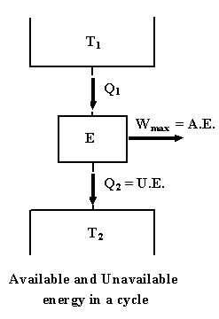

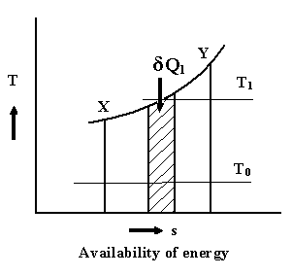

Consider a finite process X-Y , heat is supplied reversibly to a heat engine. Taking an elementary cycle, if  is the heat received by the engine reversibly at T1, then



For the heat engine receiving heat for the whole process X-Y, and rejecting heat at T0





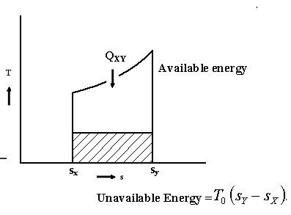

or 

The U.E. is thus the product of the lowest temperature of heat rejection, and the change of entropy of the system during the process of supplying heat.